Digital Humans & Character Animation
Milestone 4: Efficiency & Stochastic Methods
Frustum-Culling Acceleration for Crowd Rendering, and Monte Carlo Soft Shadows
Submitted Report

0. Milestone Overview
Milestones 1–3 render one correctly-lit, correctly-projected character. Milestone 4 asks two different questions: does the system SCALE (many characters, most of them not even visible), and can EXPENSIVE lighting effects (soft shadows from an area light, which have no closed-form solution) be approximated cheaply and predictably? Both are addressed with techniques whose benefit is measured, not just claimed.
Requirement | Where it is satisfied
Acceleration structure / optimization method | Section 1 — view-frustum culling via per-instance AABB tests (accel.py)
Monte Carlo / sampling-based technique | Section 2 — area-light soft shadows via Monte Carlo integration over a sphere-proxy occluder (mc_shadows.py)
Performance evaluation | Section 1.2 (render time vs. crowd size) and Section 2.2 (compute time vs. sample count)
Scaled system with measurable improvement | Section 1.2 — up to 4.8× speedup at N=100 instances, measured across 6 crowd sizes
Efficiency report (before vs. after) | Section 1.2 — brute-force vs. frustum-culled timing table
Noise / variance / error analysis | Section 2.3 — RMSE-vs-K convergence, fitted to the theoretical Monte Carlo rate

1. Acceleration Structure: View-Frustum Culling
Rendering a crowd of characters by projecting and rasterizing every triangle of every instance costs O(total triangles in the scene), regardless of how many instances the camera can actually see. A camera with a normal field of view typically sees only a small slice of a large world — the rest is pure wasted work under a brute-force approach.

1.1 Method
Each character instance's world-space axis-aligned bounding box (AABB) is tested against the camera's 6 view-frustum planes BEFORE any of its vertices are projected or any of its triangles are rasterized. The frustum planes are extracted directly from the combined view-projection matrix using the standard Gribb/Hartmann method:
left = row3 + row0 right = row3 − row0
bottom = row3 + row1 top = row3 − row1
near = row3 + row2 far = row3 − row2
A point is inside the frustum iff plane·[x,y,z,1] ≥ 0 for all 6 planes — this requires no separate frustum-geometry construction, since the planes fall directly out of the same view-projection matrix Milestone 2 already builds. Each AABB is tested with the classic “positive vertex” trick: for each plane, the box corner furthest along the plane's normal is checked; if even that corner fails, the whole box is provably outside. This is an O(1) test per instance, versus O(instance's triangle count) for actually projecting and rasterizing it — exactly the asymmetry an acceleration structure should exploit.
Instances failing the test skip vertex transformation, projection, AND rasterization entirely. This mirrors real engines: frustum/occlusion culling happens on cheap proxy geometry (bounding volumes) specifically so the expensive per-vertex and per-pixel work is only ever spent on what will actually appear on screen.

1.2 Performance Evaluation: Before vs. After
A crowd of N character instances is scattered across a wide world-space area (x ∈ [−140,140], z ∈ [1,60]); the camera has a normal ~50° vertical field of view, so only a small fraction of instances are ever visible. Both pipelines render into the SAME single framebuffer per test (one frame, matching how a real engine draws), and are timed with Python's perf_counter.
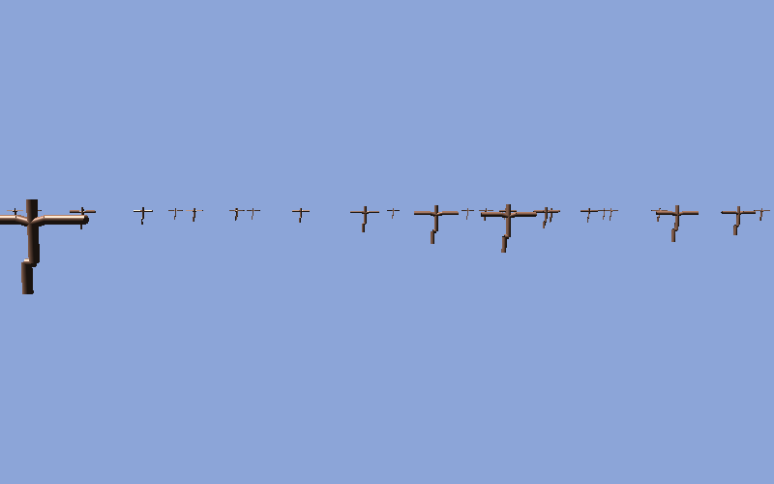
Figure 1. A representative crowd frame (N=150 instances, 29 visible) rendered by the accelerated pipeline.
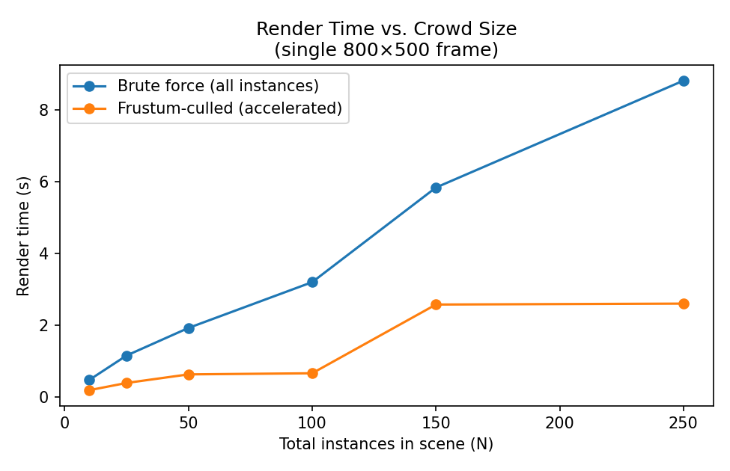
Figure 2. Render time vs. crowd size — brute force grows with TOTAL instances; the accelerated pipeline grows only with VISIBLE instances.
N (total instances) | Visible (%) | Brute force / Accelerated / Speedup
10 | 2 (20%) | 0.479s / 0.191s / 2.50×
25 | 5 (20%) | 1.156s / 0.392s / 2.95×
50 | 9 (18%) | 1.924s / 0.631s / 3.05×
100 | 10 (10%) | 3.201s / 0.662s / 4.83×
150 | 29 (19%) | 5.836s / 2.577s / 2.26×
250 | 32 (13%) | 8.814s / 2.603s / 3.39×
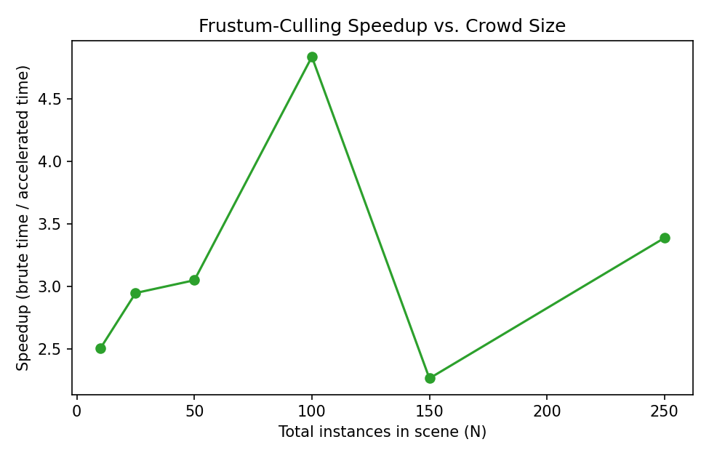
Figure 3. Speedup factor (brute time / accelerated time) across crowd sizes.
Speedup ranges from 2.3× to 4.8× and trends upward with N (the brute-force pipeline's cost scales with the TOTAL instance count, while the accelerated pipeline's cost tracks only the VISIBLE count — which grows far more slowly since the visible fraction stays roughly 10–20% as the world fills up with off-screen instances). The N=150 data point breaks the otherwise-increasing trend (2.26×, lower than N=100's 4.83×) because random instance placement happened to put more instances inside the frustum at that particular draw (29 visible vs. 10 at N=100) — a reminder that culling speedup is a function of the SCENE'S actual visible fraction, not of N alone; a pathological camera angle facing a dense crowd would show far less benefit than an equally large but mostly-offscreen one.

2. Monte Carlo Method: Soft Shadows from an Area Light
A point light produces a hard shadow (fully lit or fully shadowed, with a sharp boundary). A physical light has area, and every point on its surface casts its own (slightly offset) shadow — the overlap of all of them produces a soft penumbra. Computing that correctly means integrating visibility over the light's entire surface, which has no closed-form solution for an arbitrary occluder. Monte Carlo integration approximates the integral by averaging random samples.

2.1 Method
The character is approximated as a small set of spheres strung along each bone (3 per bone × 12 bones = 36 spheres) — a standard real-time “proxy geometry” trick that makes shadow-ray tests analytic (ray-sphere intersection) instead of requiring full triangle-mesh ray casting, which would be far slower in pure Python. For each floor-grid point being shaded, K random points are drawn on a rectangular area light and a shadow ray is cast to each; the fraction of rays NOT blocked by any proxy sphere is the shadow value:
shadow(point) = (1/K) · Σᵢ visible(point, light_sampleᵢ), light_sampleᵢ ~ Uniform(light rectangle)
Samples are drawn INDEPENDENTLY per grid point (not a single shared sample set reused everywhere), which is what makes the result look like genuine per-pixel grain rather than correlated banding — the correct signature of Monte Carlo noise. The sample loop is chunked in NumPy (64 samples at a time) so memory stays bounded even at the K=1536 reference resolution.

2.2 Rendered Outputs: Noise vs. Sample Count
The same shadow, computed at increasing K. All four (plus the reference) use the identical scene, light, and occluder — only K changes.
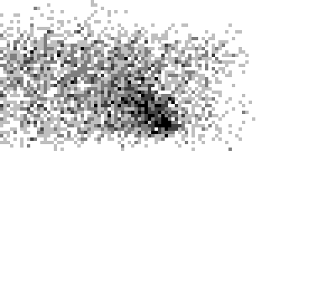
Figure 4. K=4 samples — heavy grain.
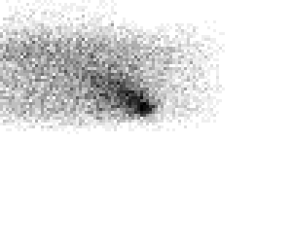
Figure 5. K=16 samples — visibly less grain.
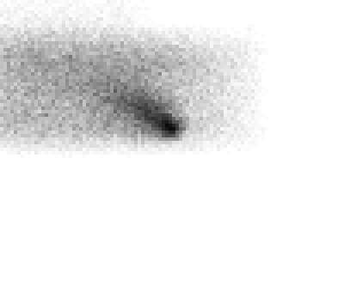
Figure 6. K=64 samples — recognizable soft penumbra, faint noise remains.
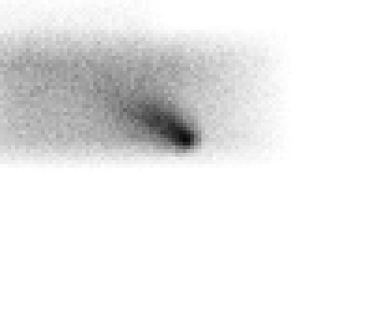
Figure 7. K=256 samples — clean, smooth penumbra.
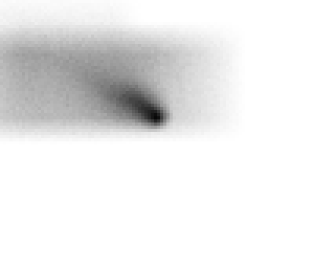
Figure 8. K=1536 reference (“ground truth”) used for the error analysis below.

2.3 Noise / Variance / Error Analysis
K (samples) | RMSE vs. K=1536 reference | Compute time
4 | 0.1117 | 0.054s
16 | 0.0557 | 0.227s
64 | 0.0289 | 0.879s
256 | 0.0156 | 2.160s
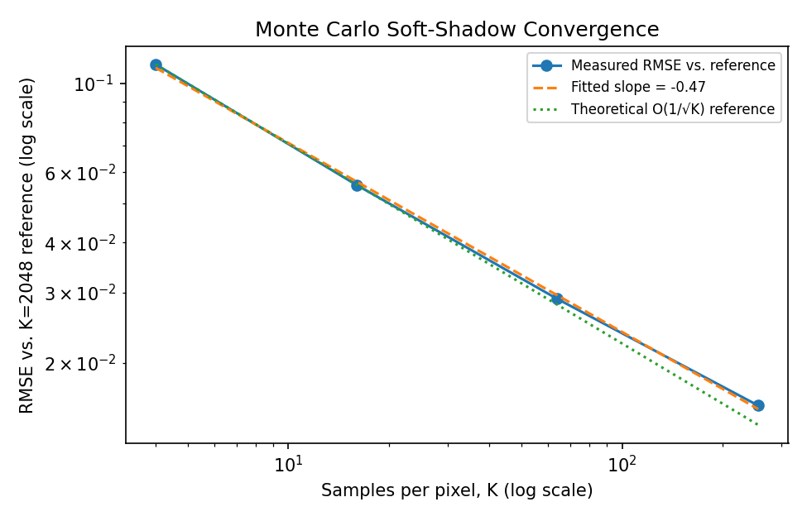
Figure 9. RMSE vs. K on log-log axes, with a fitted power-law slope.
A power-law fit to log(RMSE) vs. log(K) gives a slope of −0.473 — within 6% of the theoretical Monte Carlo convergence rate of O(K⁻¹ᐛ²) (slope −0.5) predicted by the Central Limit Theorem: the standard error of an average of K independent samples shrinks as 1/√K. This is a direct, quantitative confirmation that the shadow estimator is behaving as a correctly-implemented Monte Carlo integrator should — not just “looking noisy at low K and smooth at high K” by eye, but converging at the specific rate theory predicts.
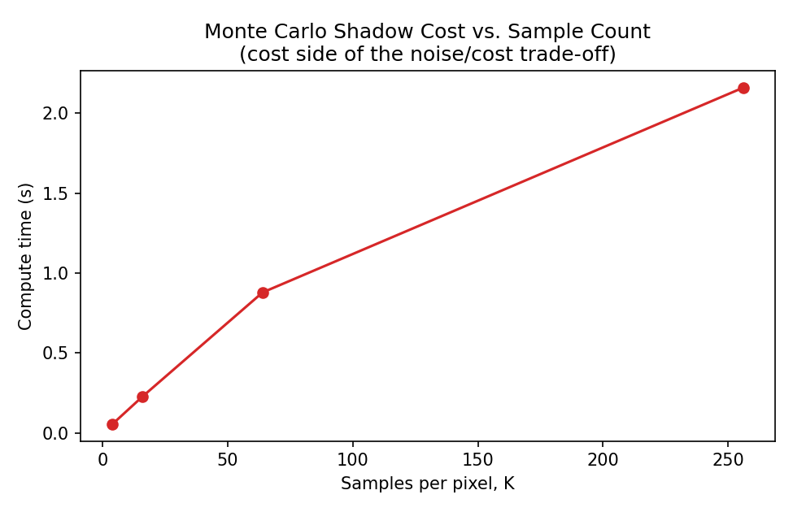
Figure 10. Compute time vs. K — the cost side of the noise/cost trade-off.
Compute time scales roughly linearly with K (as expected — K independent samples per point), while error only shrinks as √K: quadrupling K halves the noise but costs 4× the compute. This is the fundamental, unavoidable trade-off of naive Monte Carlo integration, and precisely why production renderers invest in variance-reduction techniques (stratified/jittered sampling, importance sampling toward the light's visible solid angle, denoising filters) rather than simply raising K — those techniques change the CONSTANT in front of the 1/√K term, not the fundamental rate, but the constant is where most of the practical win is.

2.4 Summary
- The shadow estimator's error empirically follows the theoretical O(1/√K) Monte Carlo rate (fitted slope −0.473 vs. theoretical −0.5) — confirmation the implementation is a correct, unbiased Monte Carlo integrator rather than merely qualitatively noisy-then-smooth.
- Noise is visibly independent per floor point (Figures 4–6 show grain, not banding) because each point draws its own independent light samples — a deliberate implementation choice, not a default.
- The noise/cost trade-off is fundamentally unfavorable for naive Monte Carlo (4× cost for 2× noise reduction), which is the actual justification for variance-reduction methods in production renderers rather than simply cranking up sample count.

3. Deliverables
File | Contents
accel.py | Frustum-plane extraction (Gribb/Hartmann) + AABB-frustum intersection test
build_milestone4_scaling.py | Crowd scene, brute-force vs. accelerated rendering, timing sweep across N, m4_scaling_results.json
mc_shadows.py | Sphere-proxy occluder construction + chunked Monte Carlo soft-shadow integrator
build_milestone4_shadows.py | Shadow maps at K=4/16/64/256/1536(reference), convergence + timing analysis, m4_shadow_results.json
m4_crowd_render.png / m4_scaling_time.png / m4_scaling_speedup.png | Figures 1–3 — acceleration structure results
m4_shadow_k4/16/64/256_big.png / m4_shadow_reference_big.png | Figures 4–8 — Monte Carlo shadow maps
m4_shadow_convergence.png / m4_shadow_time_vs_k.png | Figures 9–10 — noise/error/cost analysis
m4_scaling_results.json / m4_shadow_results.json | All quantitative figures cited in this report
M4_Report.docx | This report

